aIT, IKT -> IP telefonie

Voice over Internet Protocol

Voice over Internet Protocol (VoIP) is a technology that allows voice calls to be made over a broadband Internet connection instead of an analog (regular) telephone line. Some VoIP services allow you to call people using the same service, but others allow you to call anyone with an analog phone. They may or may not have a phone number - including local, long distance, mobile and international numbers. Some VoIP services only work through your computer or a dedicated VoIP phone, while other services allow you to use a traditional phone connected to a VoIP adapter

The main advantages include lower call costs and greater flexibility in call management, however, for proper use, it is important to ensure a good network connection and low latency to minimize communication delays.

How VoIP works
VOIP works by converting analog audio signals into digital data, which is then transmitted over Internet Protocol (IP).
The VOIP communication process consists of several steps:
• Voice digitization - the voice signal is digitized using a codec, which is a program that converts an analog signal into a digital format.
• Data compression - digital data is compressed to enable more efficient transmission over the Internet.
• Data transmission - digital data is transmitted via Internet Protocol (IP).
• Data decompression - the received data is decompressed to the original digital format.
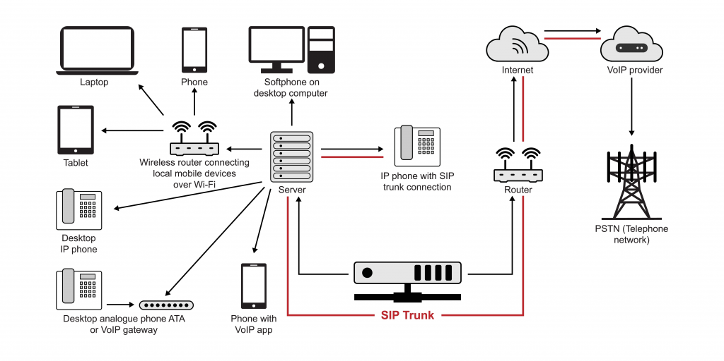
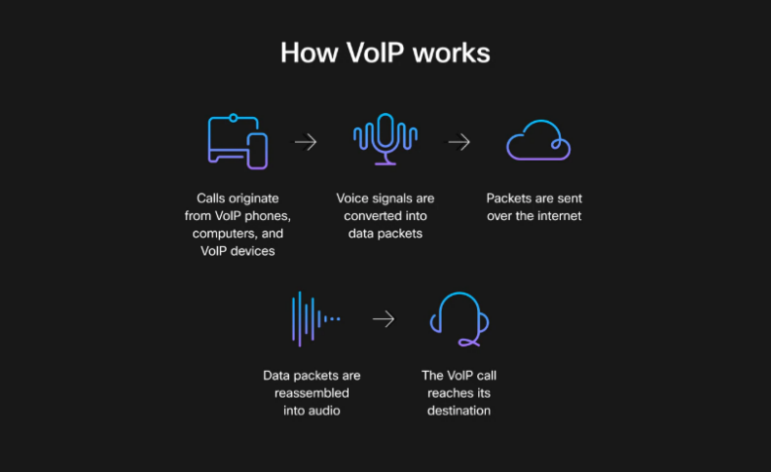
• Conversion back to analog signal - digital data is converted back to analog signal for voice reproduction.

Necessary hardware and software for VoIP implementation
In order to be able to call via IP telephony, it is necessary to have at least one of the following hardware or software solutions:
• VOIP gateway - a device used to connect analog telephone lines with Internet telephony. A VOIP gateway allows you to convert calls from traditional telephone lines to a digital format and transmit them over the Internet network, and vice versa, to receive calls from Internet telephony and convert them to analog signals that can be transmitted over traditional telephone lines.
VOIP gateways are typically used by businesses or households that still use traditional phone lines but want
to take advantage of Internet telephony.
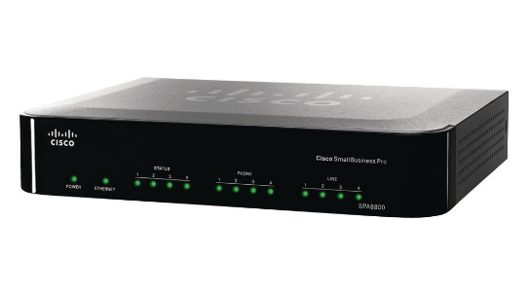

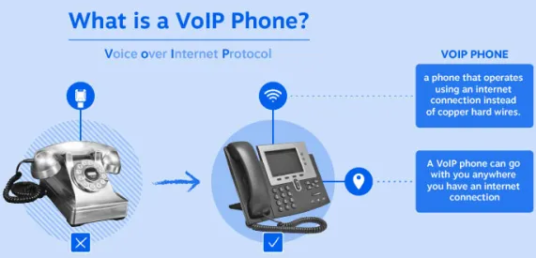
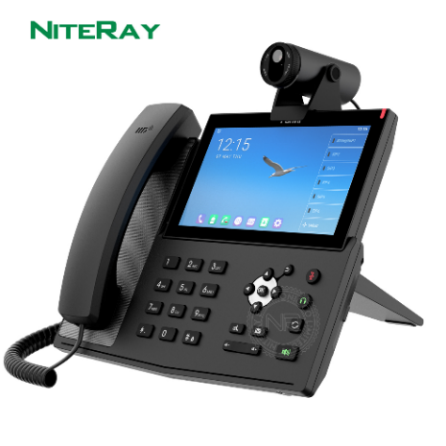
• IP telephones - devices with an RJ-45 Ethernet connector or a wireless connection via Wi-Fi, which look and act like normal analog telephones, but connect directly to your network router. These devices come with all the necessary hardware and software for IP calling. Some IP phones can even be powered by different well-known operating systems such as Android or Linux.

• Software client - it is a program that you can install on your computer, smartphone or tablet. The software client connects to your IP phone network over the Internet and allows you to make calls using the headset and microphone on your device. A software client can have similar features to an IP phone, such as call switching, messaging and contact management. There are plenty of free VoIP clients on the market today, such as Linphone,Jytsi, MicroSIP, and others, which are designed for a wide variety of operating systems.

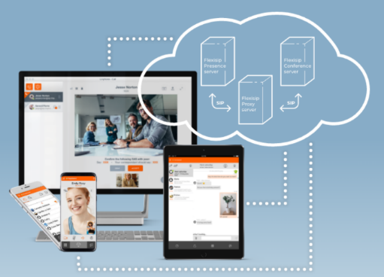

Important features of VoIP:
• Auto-Attendant - "Electronic receptionist" - automatic call forwarding.
• Video Conferencing – Safe and hassle-free face-to-face video.
• Voicemail Transcription – Access voice messages even easier by receiving them as transcribed text sent via email or text message.
• Instant Messaging (IM) - Send and receive text messages, pictures and multimedia files from a phone number, website or mobile applications.
• Mobile and local number portability – Switch from one phone system to another while keeping your existing phone numbers.
• Presence Panel - Shows who is available to answer the call, who is busy, etc.
• Call Forwarding – Create rules that automatically forward callers to the next available person or department.
• Ring groups - Allows all extensions within the group to ring simultaneously.
• Incoming call queues - Allows you to distribute and route calls accordingly.
• Music on hold – Allows callers to listen to music, recorded audio or customized marketing messages while on hold.
• Call recording – Allows you to record calls and play them back.
• Call analysis – Enables traffic analysis, call history or user statistics.
Questions

• What is VoIP?
• How does VoIP work and in what three hardware/software ways can VoIP be implemented?
• What are the main features and benefits of VoIP?
• What is the purpose of a VOIP gateway in IP telephony and how does it work?
• What are IP phones and how do they connect to the network?
• What is a software client for VoIP communication?

